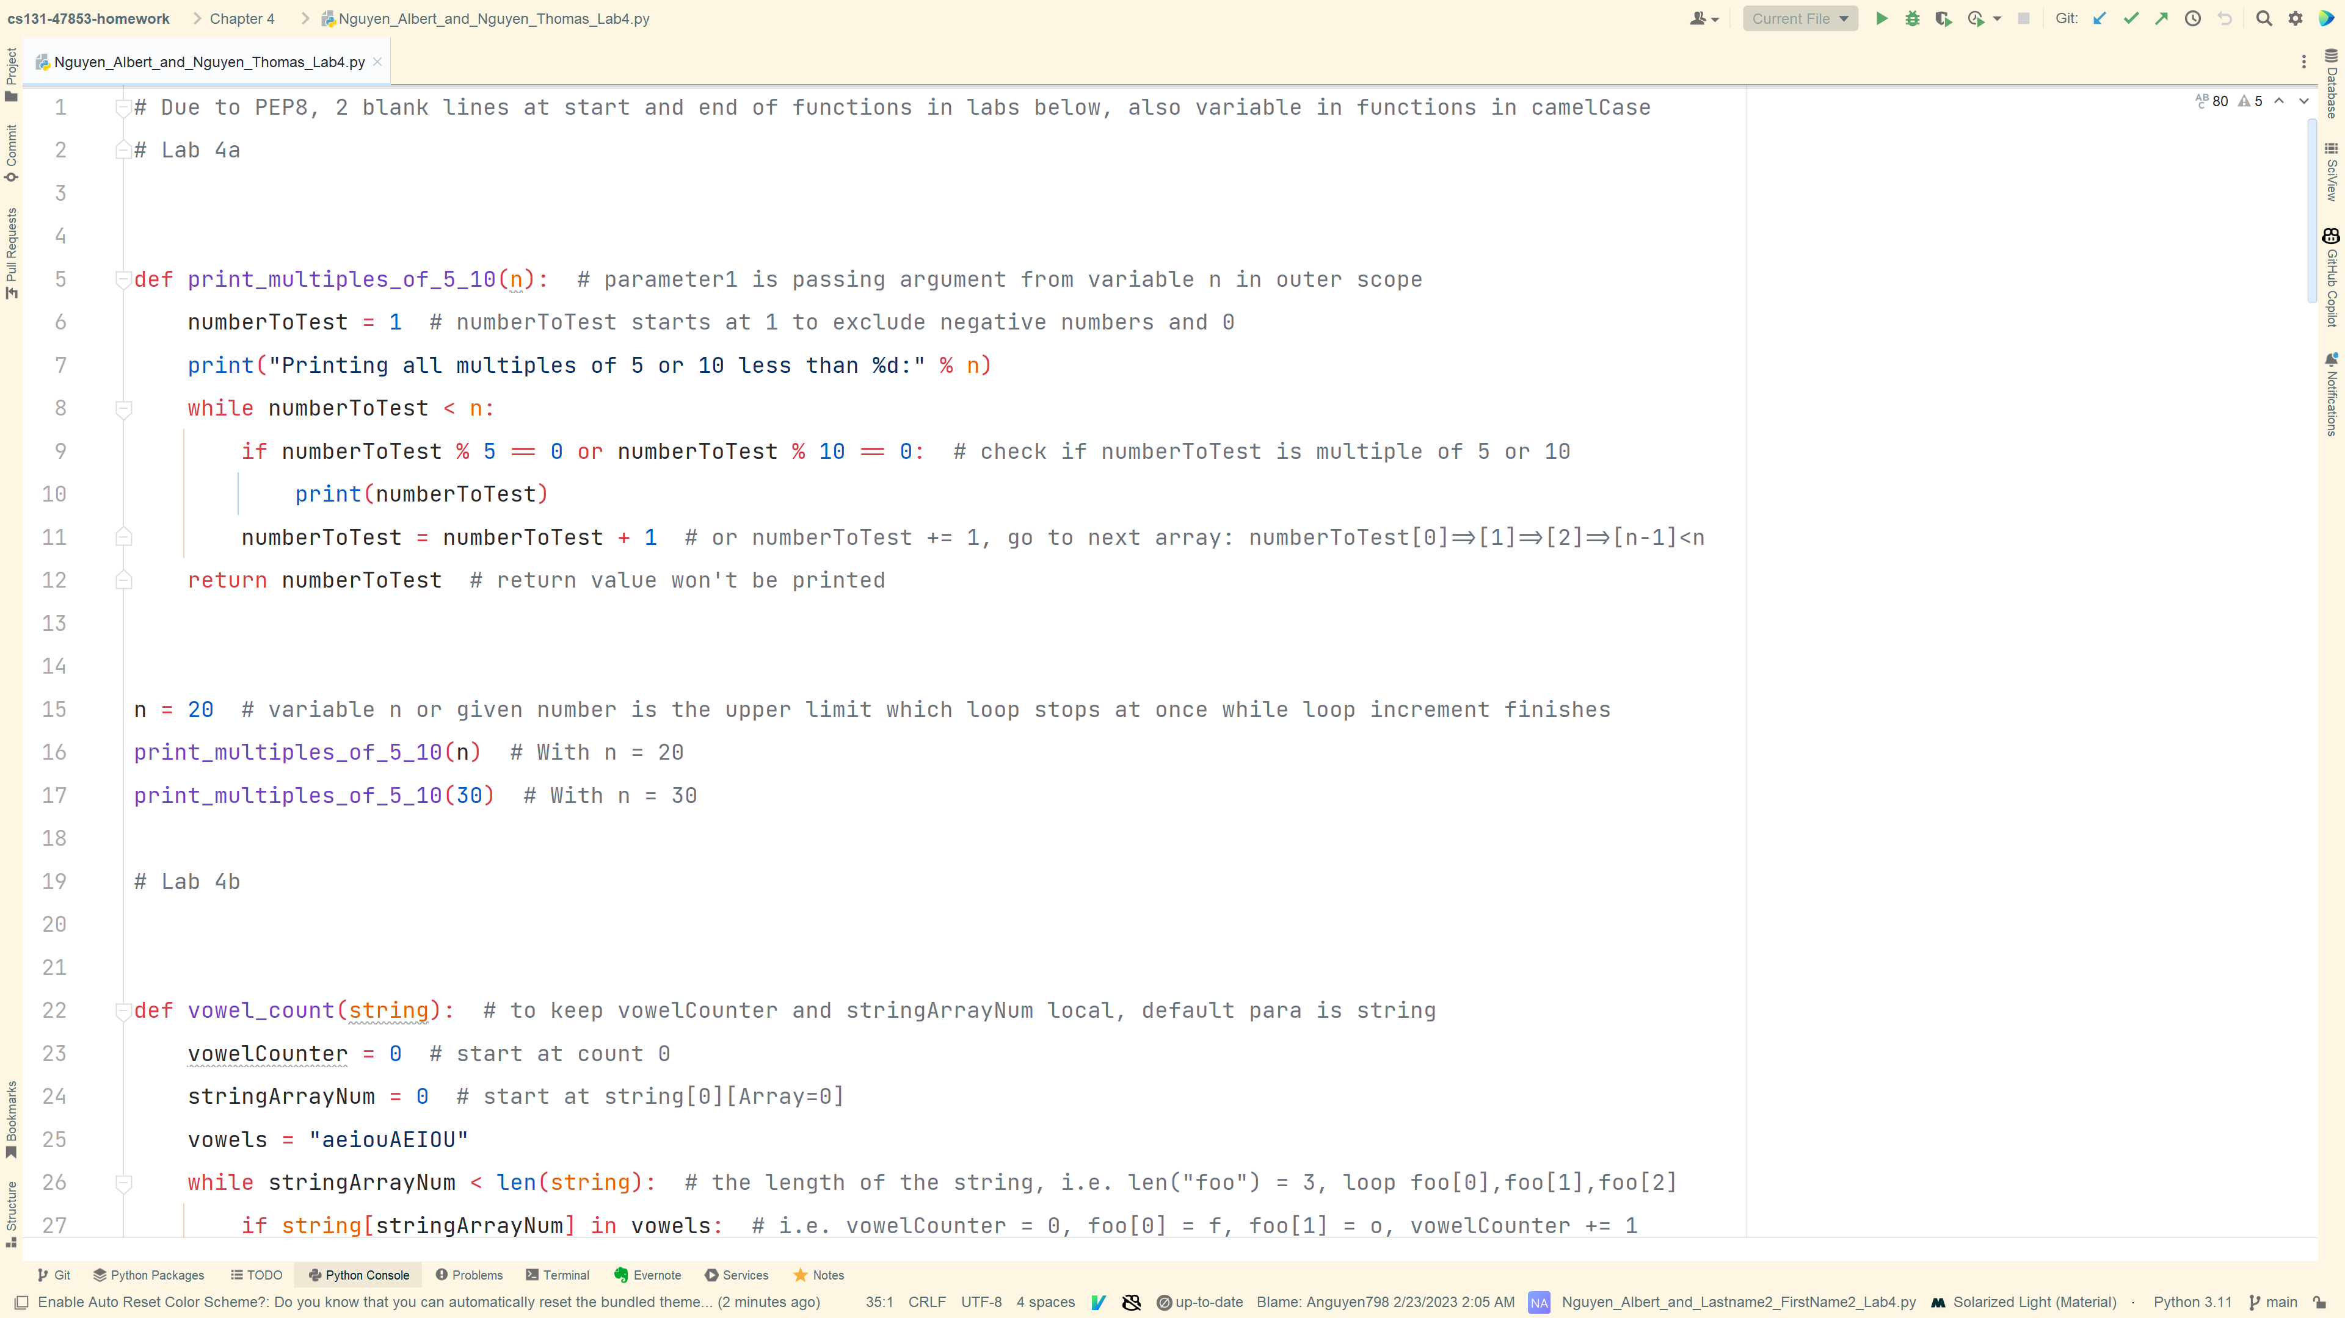

4a_Code

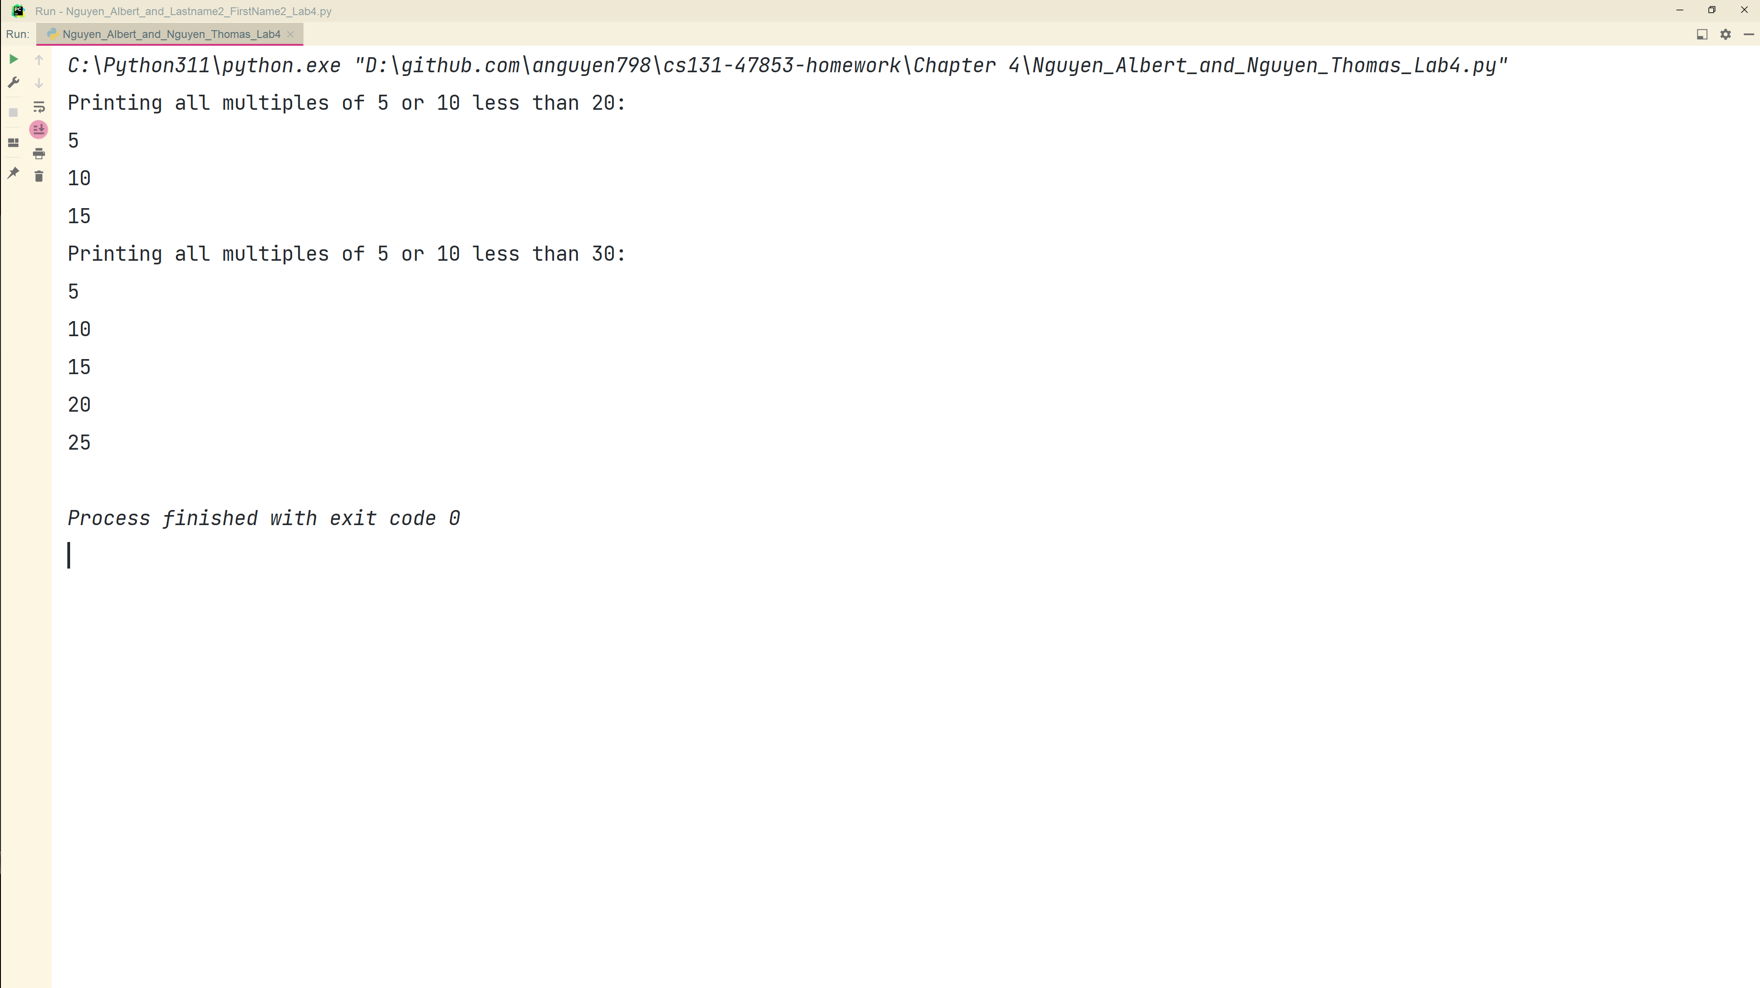

4a_Output

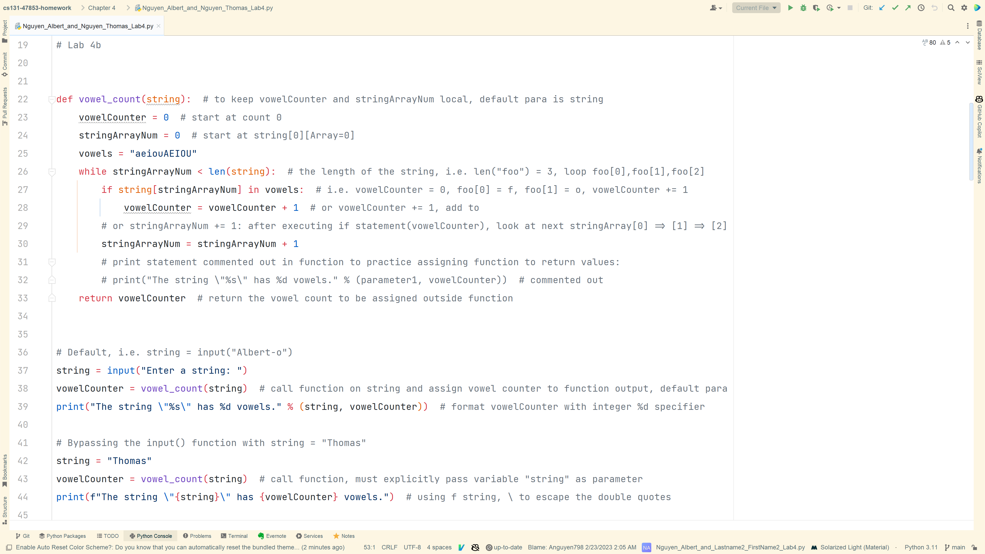

4b_Code

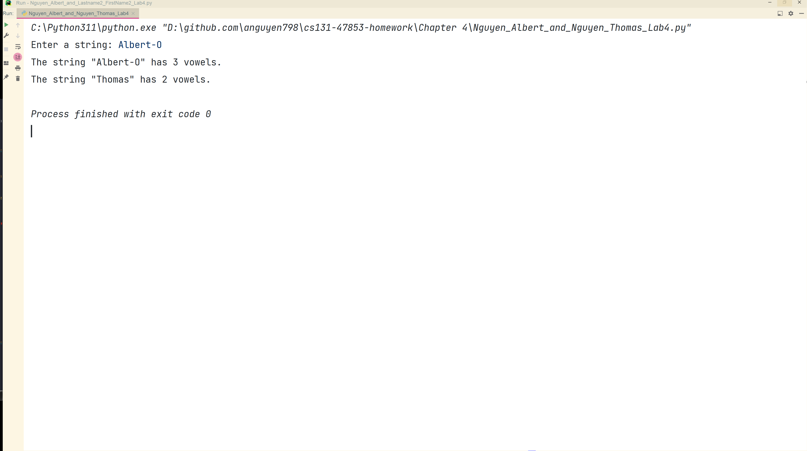

4b_Output



4c_Code

4c_Output

4d_Code

4d_Output

4e_Code

4e_Output

4f_Code

4f_Output

4g_Code

4g_Output

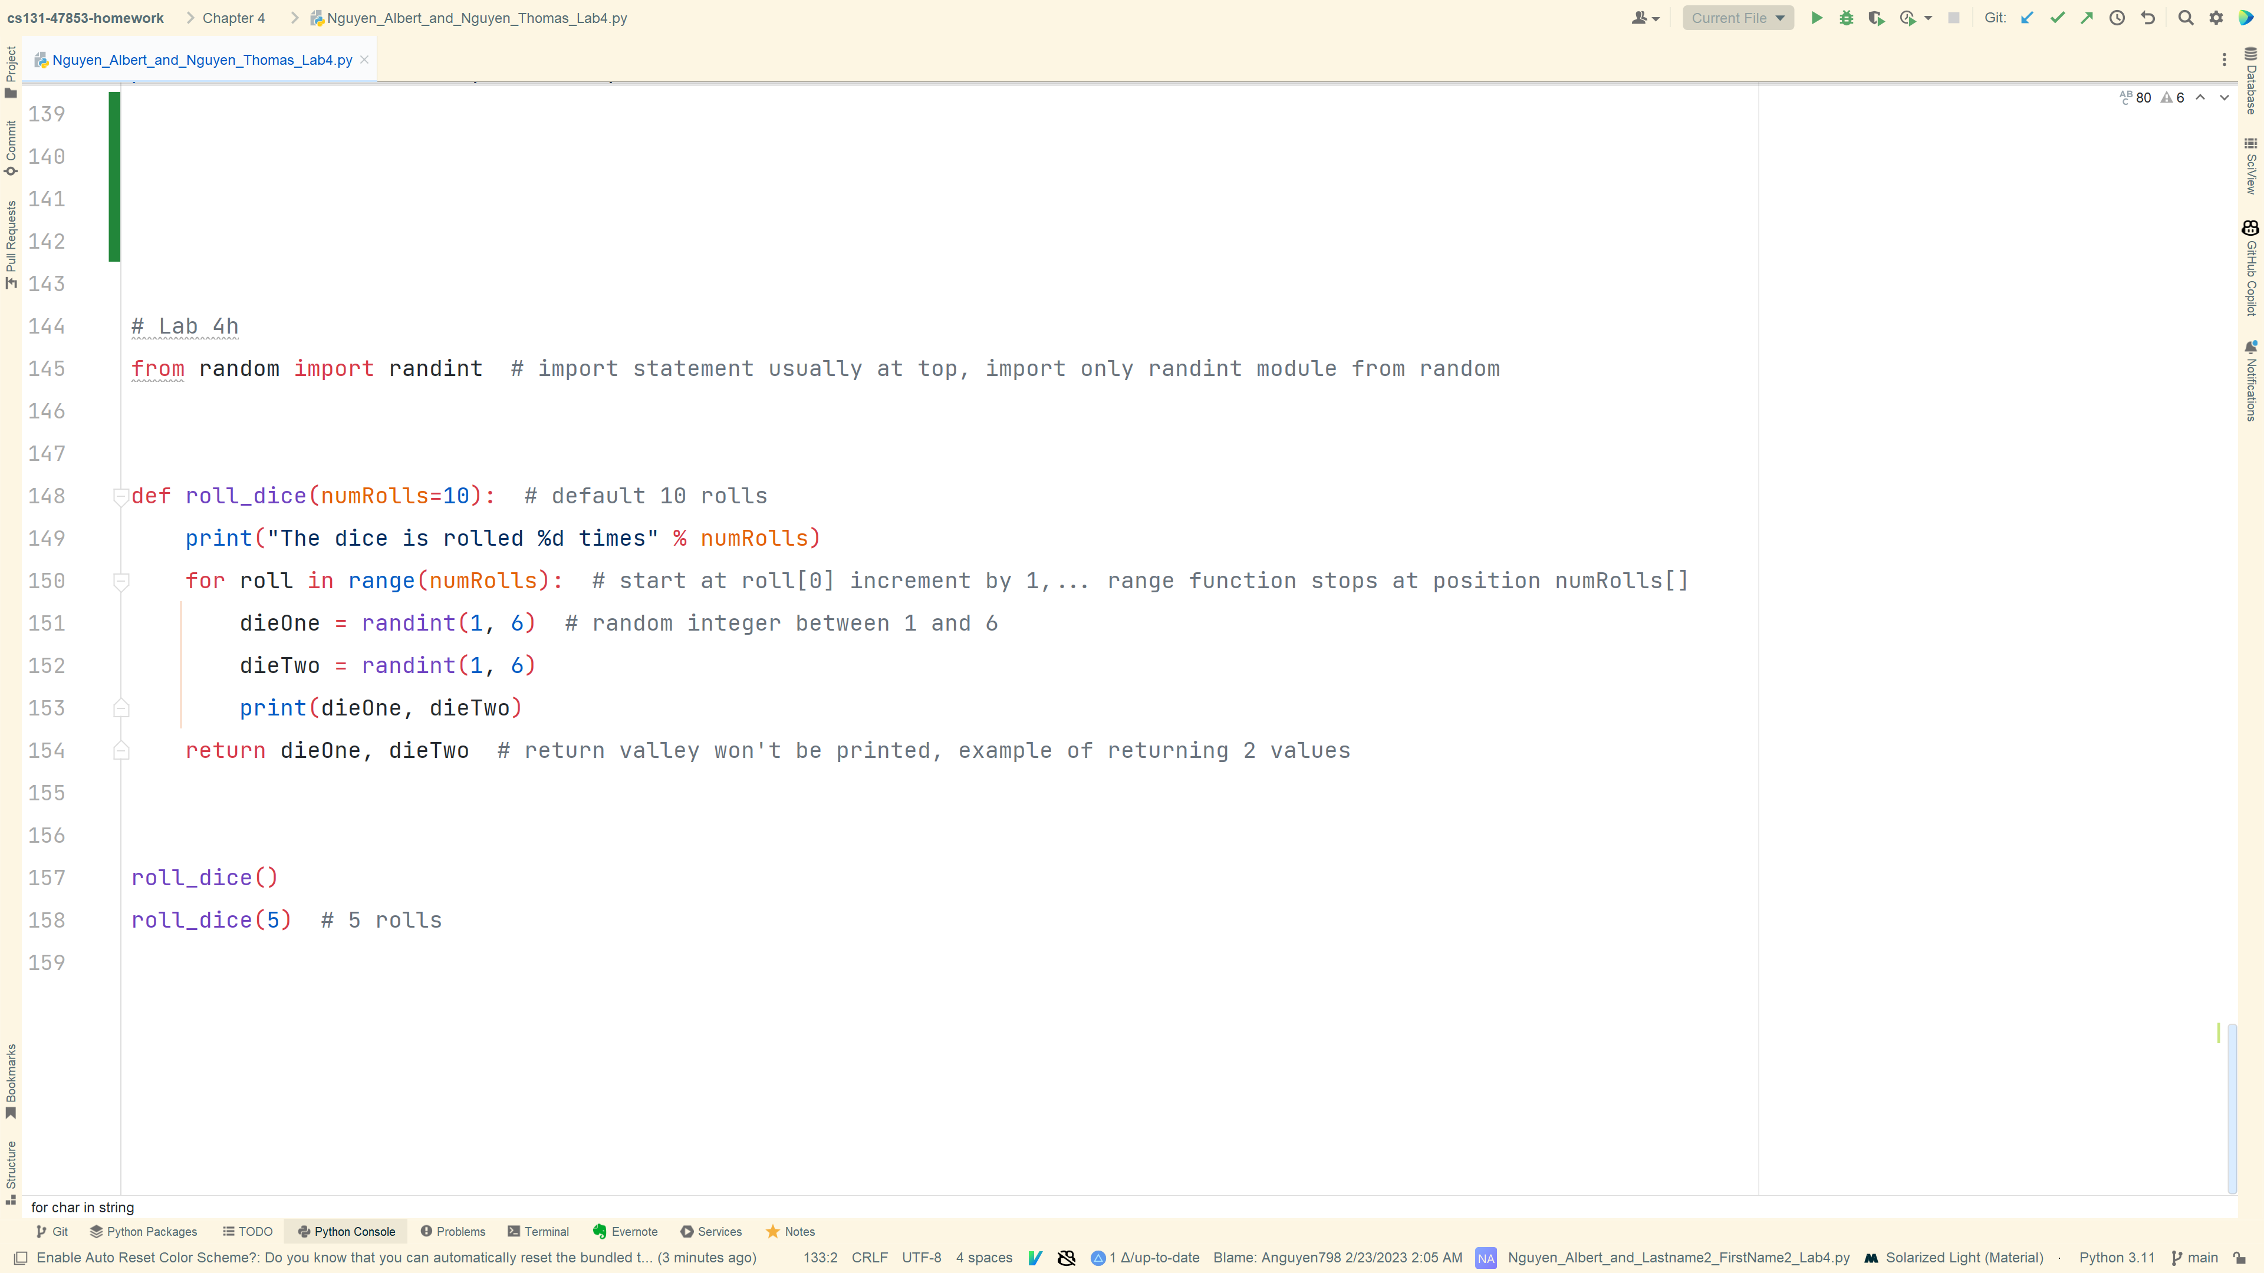

4h_Code

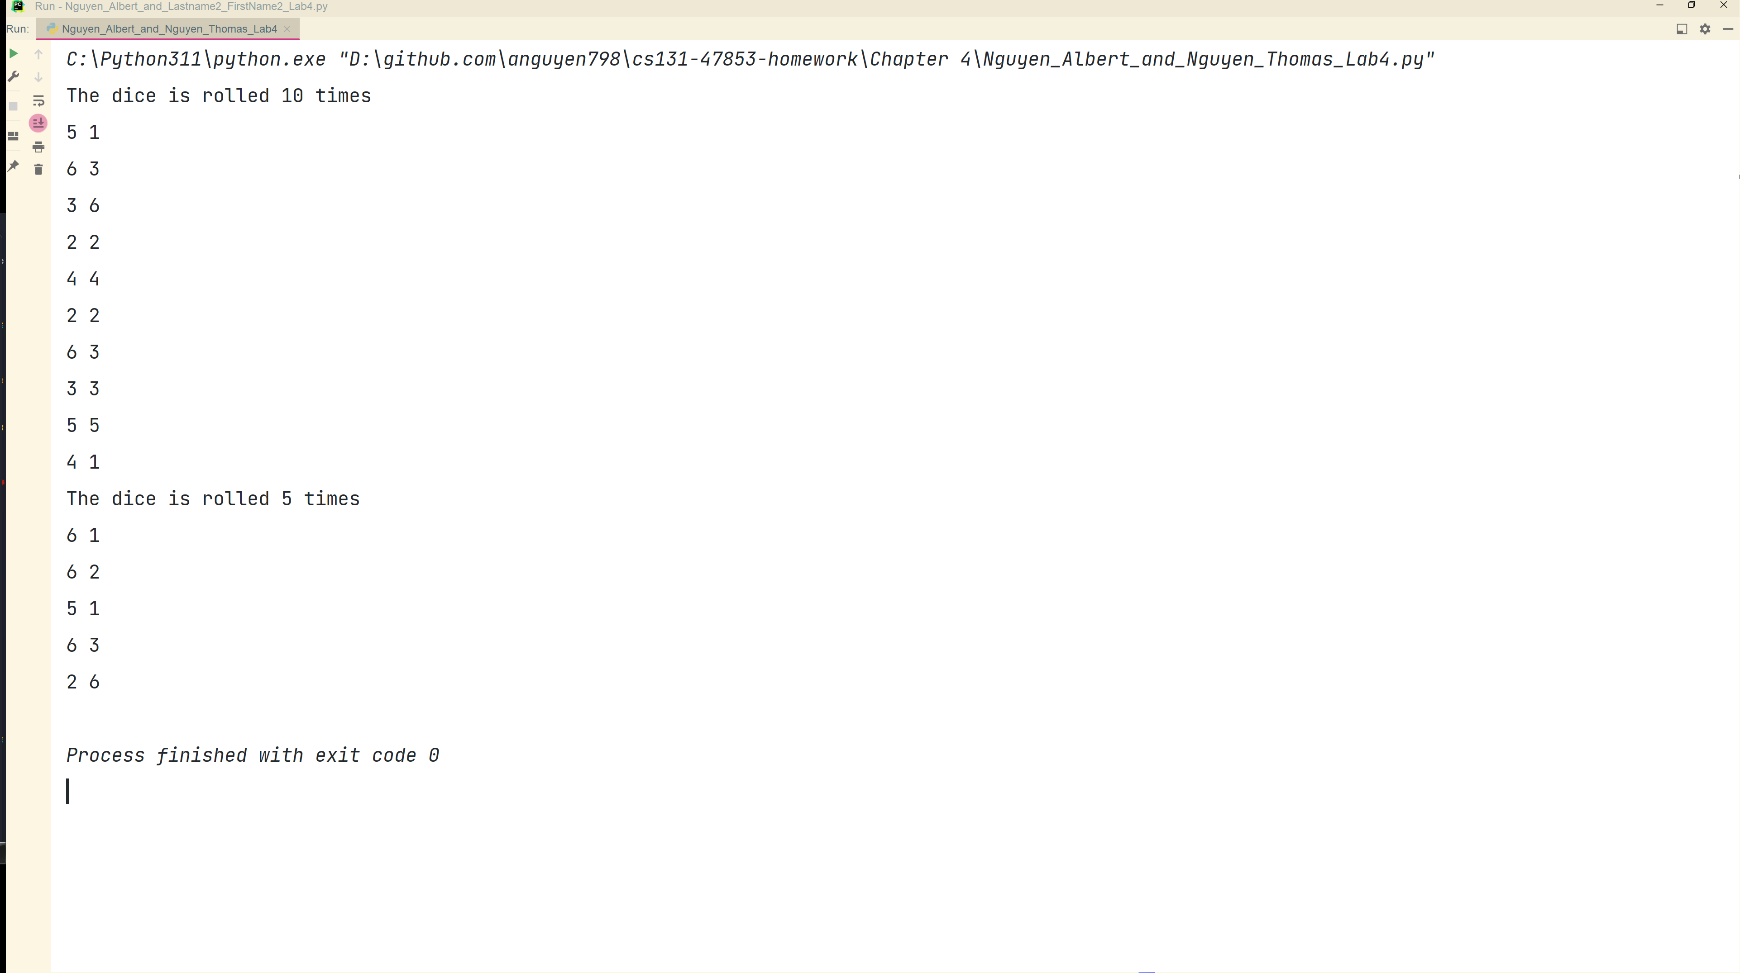

4h_Output

4a_Code
4a_Output
4b_Code
4b_Output
4c_Code
4c_Output
4d_Code
4d_Output
4e_Code
4e_Output
4f_Code
4f_Output
4g_Code
4g_Output
4h_Code
4h_Output

